Enter Time

Overview
This job aid outlines the process for an Employee to enter time in Workday

Steps
- From the Workday Home page, click the Time worklet
- Under Enter Time, click This Week
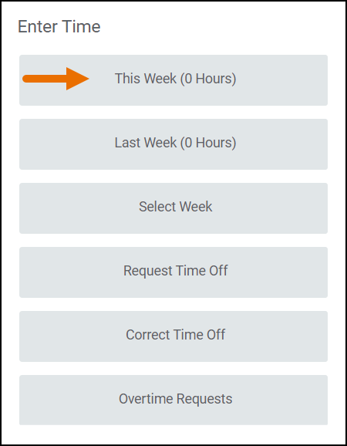
The Time Calendar will display
  - You can click the previous or next arrows to navigate to a time frame other than the current week

- Click on the Day / Date for which you need to enter time worked. A blue Enter Time box should appear, and then a pop-up will display
  - If you have more than one position, make sure you are using the right title for the time you are entering. You can select your different positions under the position drop down
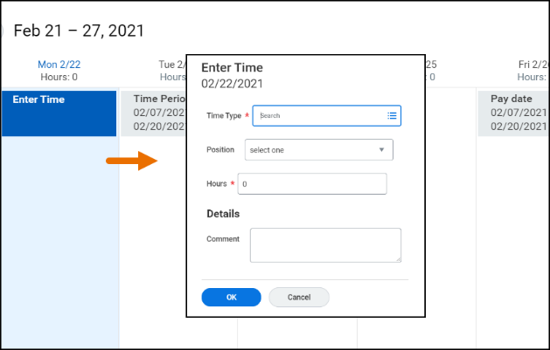
- Enter the number of Hours worked for that date
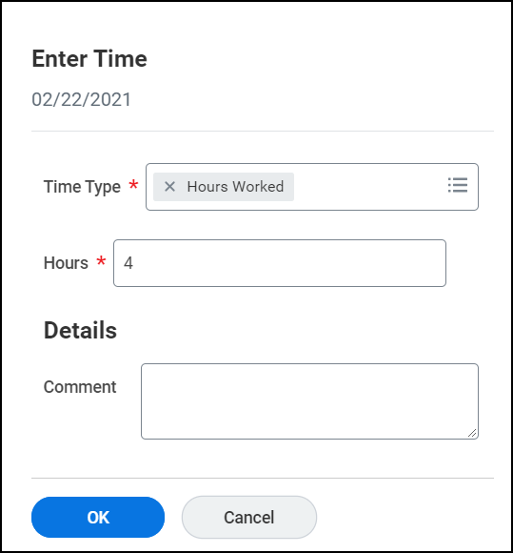
- Click OK. You will see that the time has been added to the calendar
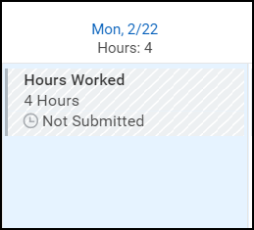
Note: You can click Actions at the top of the page to view a drop-down list of options. From there, you can select various options pertaining to time entry
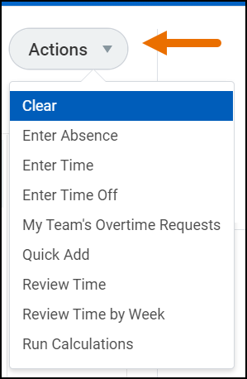
- Click Review when you have populated all your entries for the week. The Submit Time summary page will display. Review the time entered
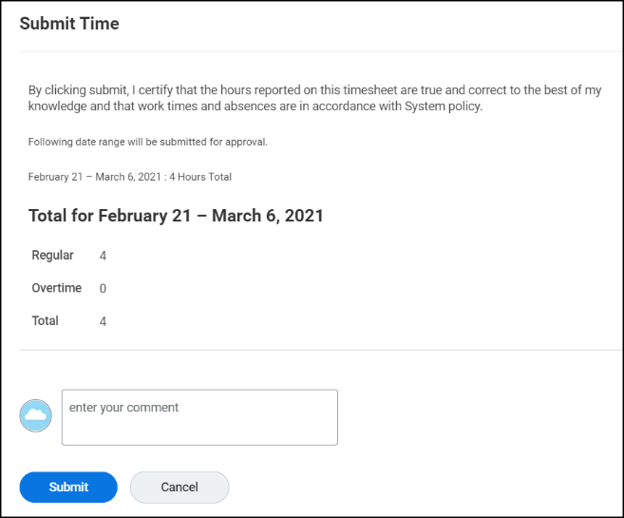
- Enter any comments, as needed
- Click Submit
The request will be routed to your Manager for approval
This completes the Enter Time process for Employees

